Quiz Answers
- What is a Program?
A program is a group of instructions that tells the computer what to do. It consists of a bunch of statements displayed in written words and symbols that can be understood and carried out by a computer to perform a specific task. According to Rainer “The process of writing or coding, programs is called programming. The person who writes a program is a programmer.” (Rainer, Turban, & Potter, 2010)
- What is programming?
A program uses programming to solve a problem, such as programming payroll or invoice. Some examples of structures used in programming such as the structures used when programming payroll are: sequence, decisions and loop.
- What is a programming language?
A programming language is the language that computers understand. There are two kinds of language: one that the computer (machine) understands inherently (born with it and is called machine language (lowest level- Intel company), and non-machine language (higher level like C++) which needs to be translated (complied) to a machine language. According to Rainer, “Programming Languages provide the basic building blocks for all systems and application software….allows people to tell computers what to do and are the means by which software systems are developed.” (Rainer, Turban, & Potter, 2010)
- What is a complier?
A Compiler is a program (software) that translates and that converts high level language (C++; is a language) to lower language (machine language).
One important job of compiler is to report errors before the translation take place. A compiler facilitates the process of converting the source code into a running program.

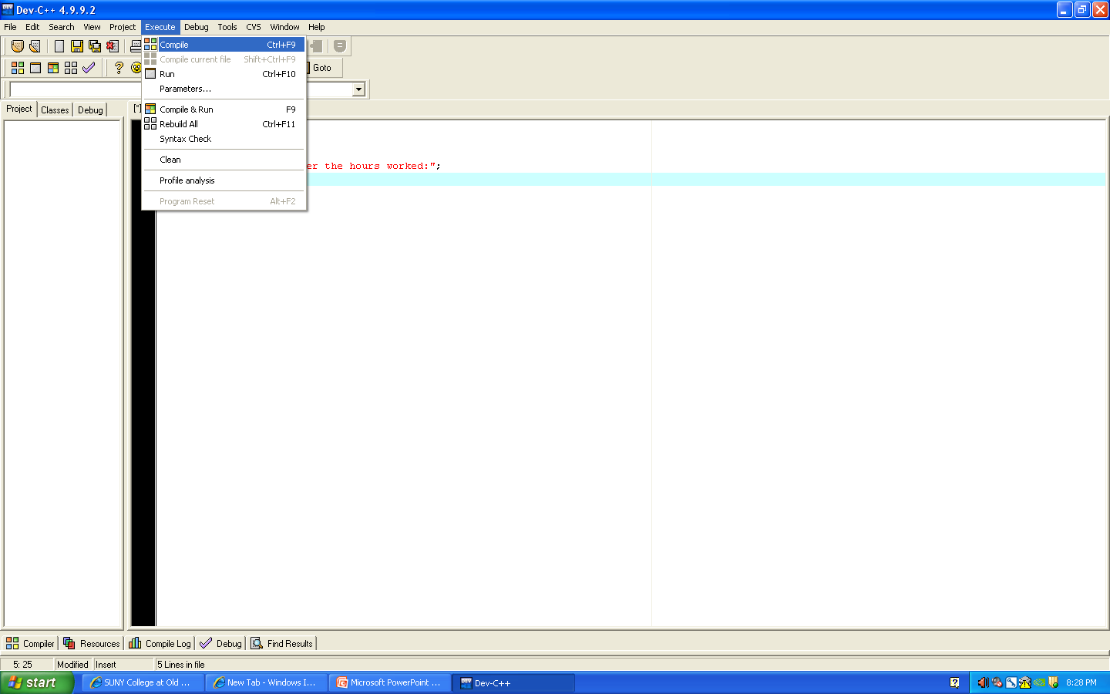

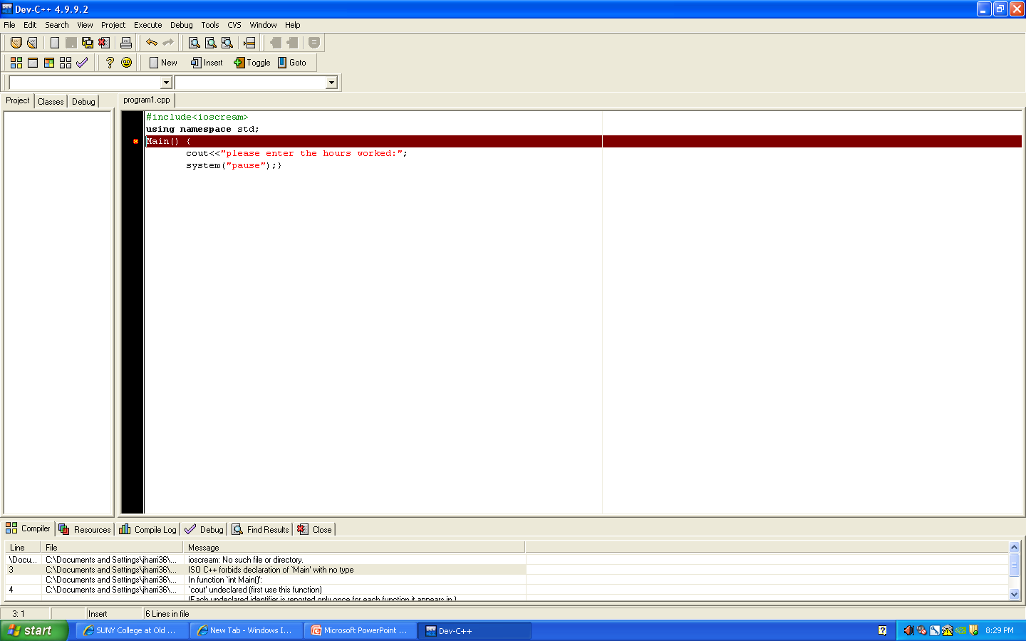

- Where do I get a complier?
There are several software companies (Microsoft) that sell a compiler for a language; with a price range of $30 to $1000. Some companies provide a free compiler and you may download a compiler from the Internet such as Dev C++ compiler from http://www.bloodshed.net . You will need a compiler to create/compile a program.

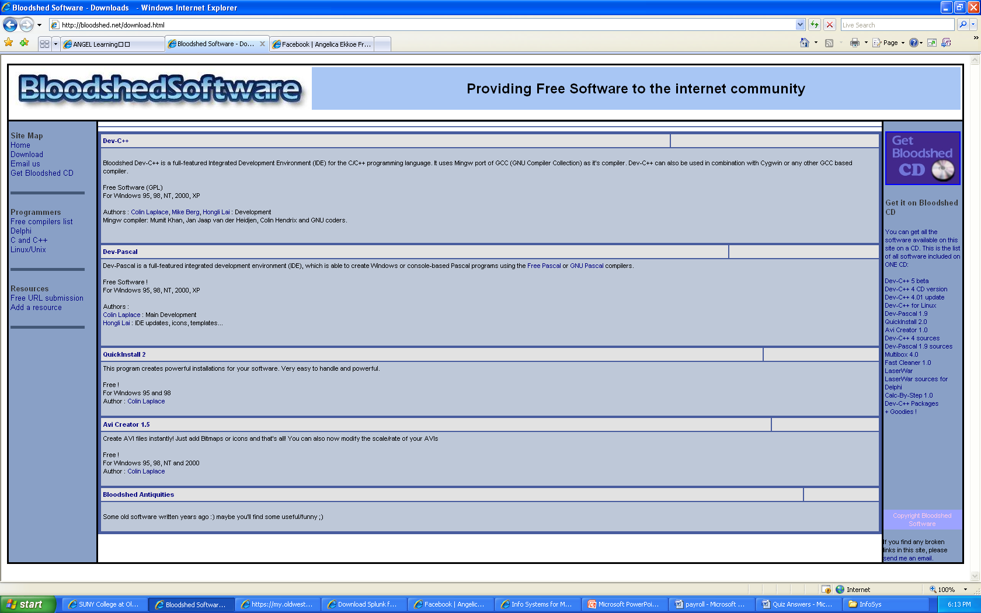

- The importance of programming :
a) Everything in the computer is programmed
b) An application such as Microsoft Words was one day a program and now users like you are able to use it to edit a document.
c) Google and Yahoo was a program before users could use these search engines.
d) Programming is the process of writing a program, which is used by a computer to execute a specific task. Therefore, without programming, computers would not be able to perform these tasks, such as calculating payroll.
- How do you download a complier?
Just go to the company site (http://www.Bloodshed.net or http://www.microsoft.com) and click on the download and wait until it is downloaded. After you access http://www.Bloodshed.net , click the download option and the following screen will appear, scroll down to the download options:
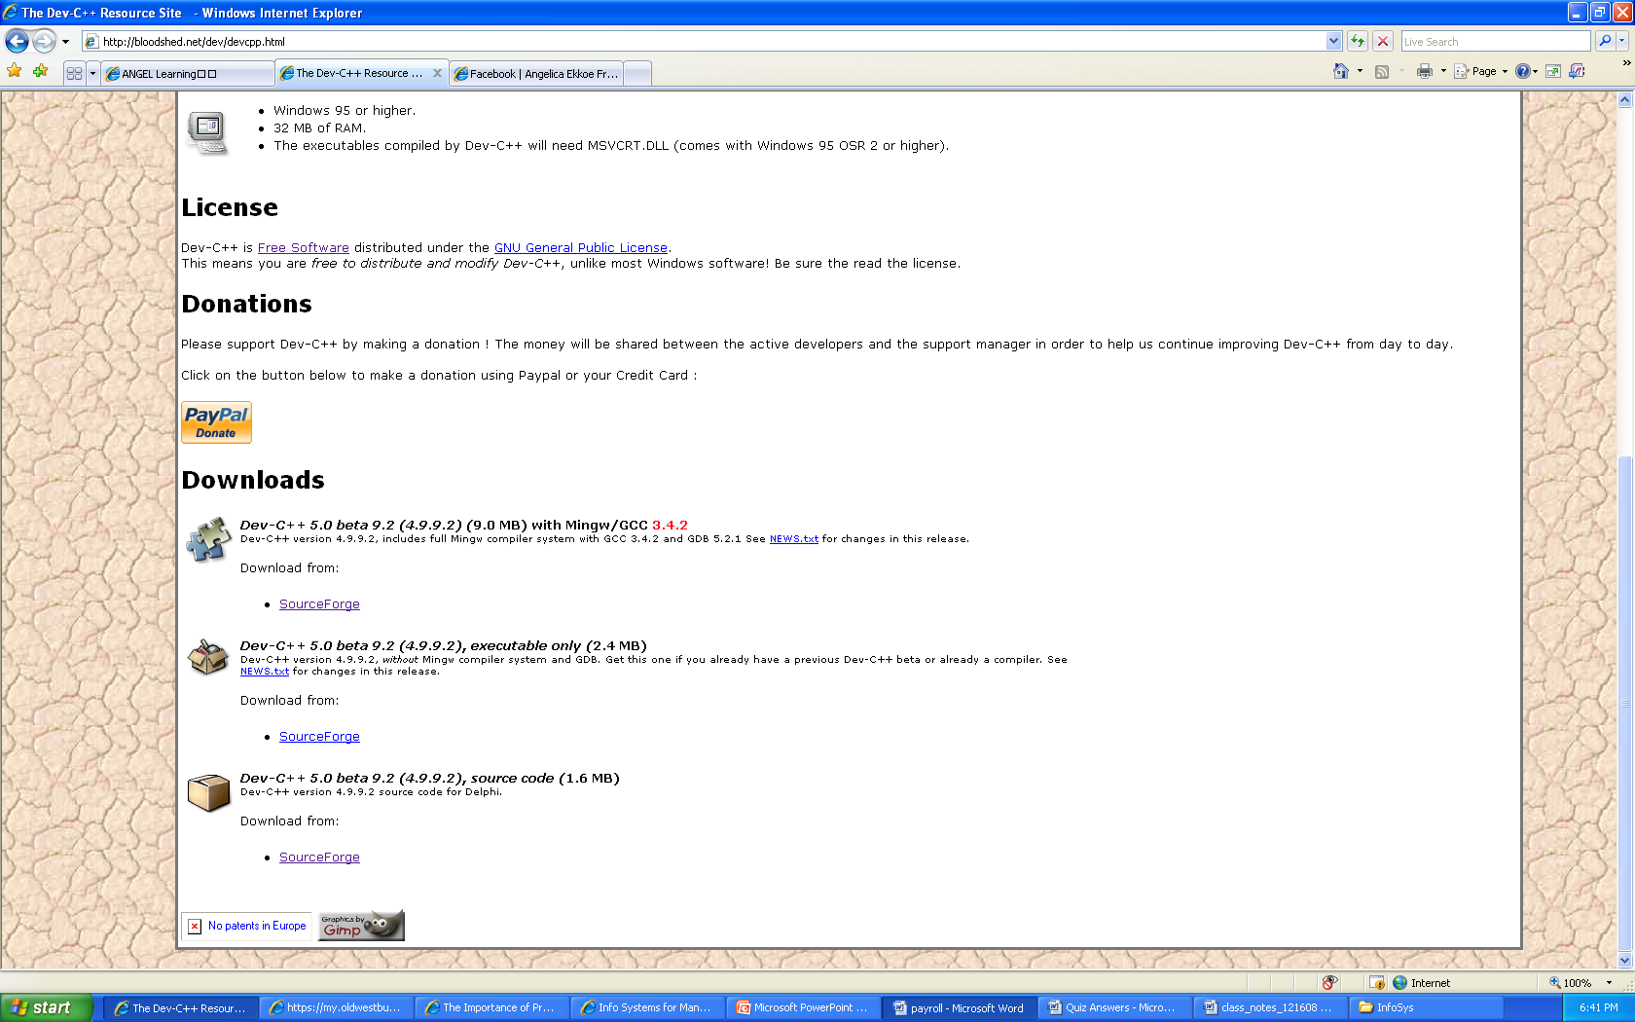

Select the source forge option and the following will appear:

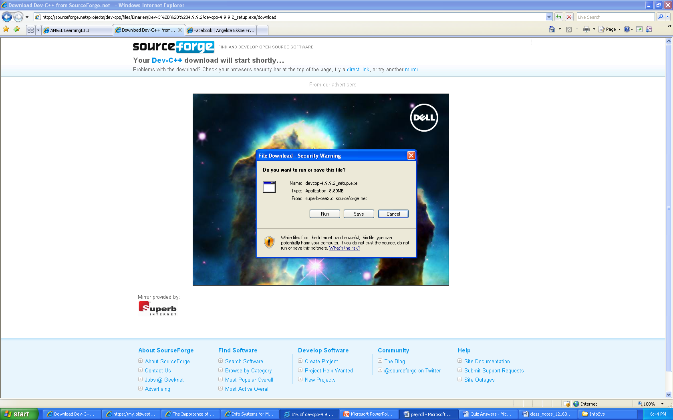

Select the run option:

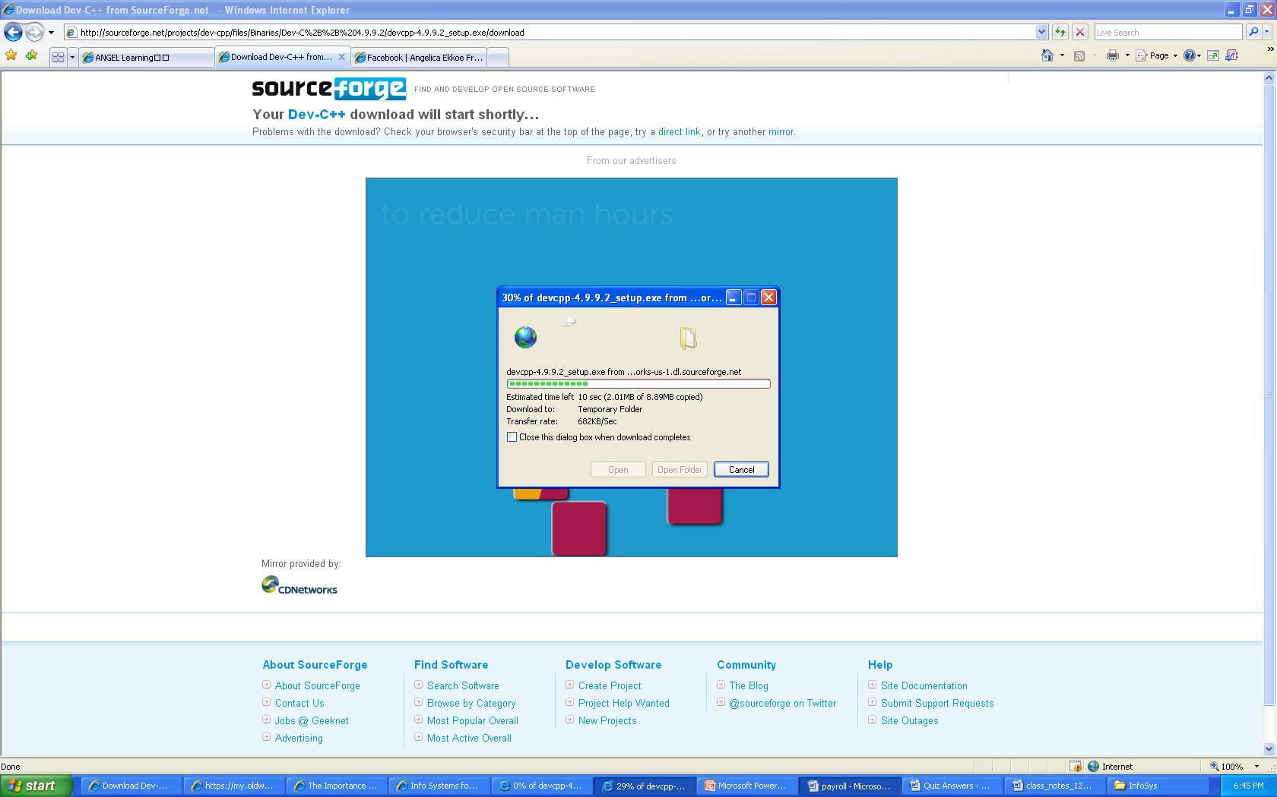

Follow through with the installation

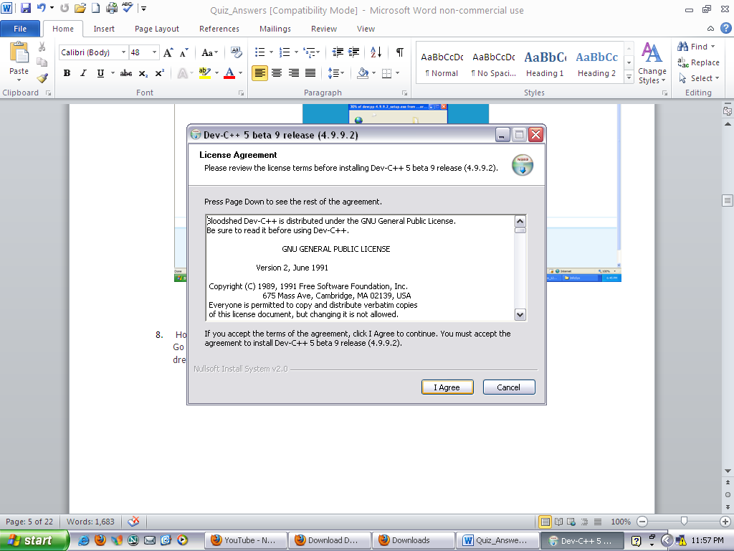

Dev C++ will begin to run after installation. It needs to be configured the first time you use it.
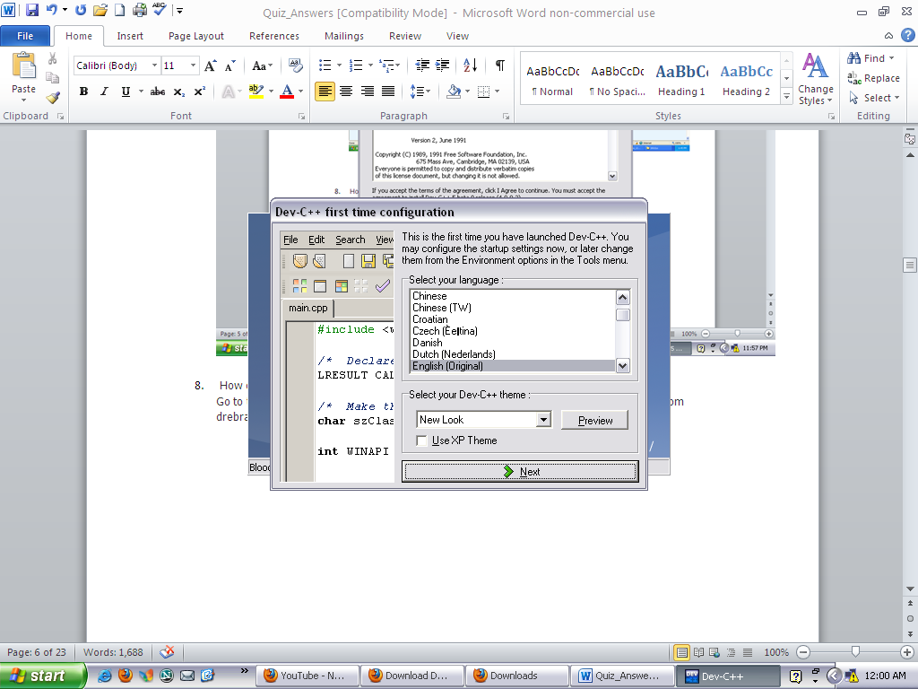

The following screen will appear after configuration

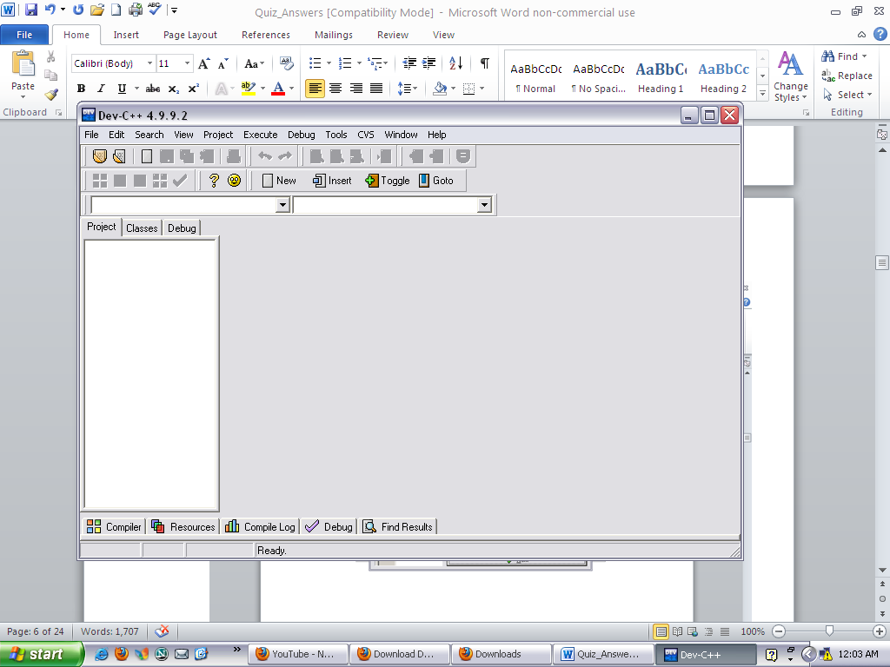

- How do you write a program in C++ language?
Go to the compiler and open a new source file and type a program line by line finding it from drebrahimi.com.

Select the C++ & OOP button at the top of the page.

Click the Dev C++ option on the left side of the page which opens up screenshots to help you with building your program.

The following steps will demonstrate how to access the compiler and source file.

After the download, click the start button at the bottom of your computer screen ‘the task bar’. Then click on Bloodshed Dev C++.
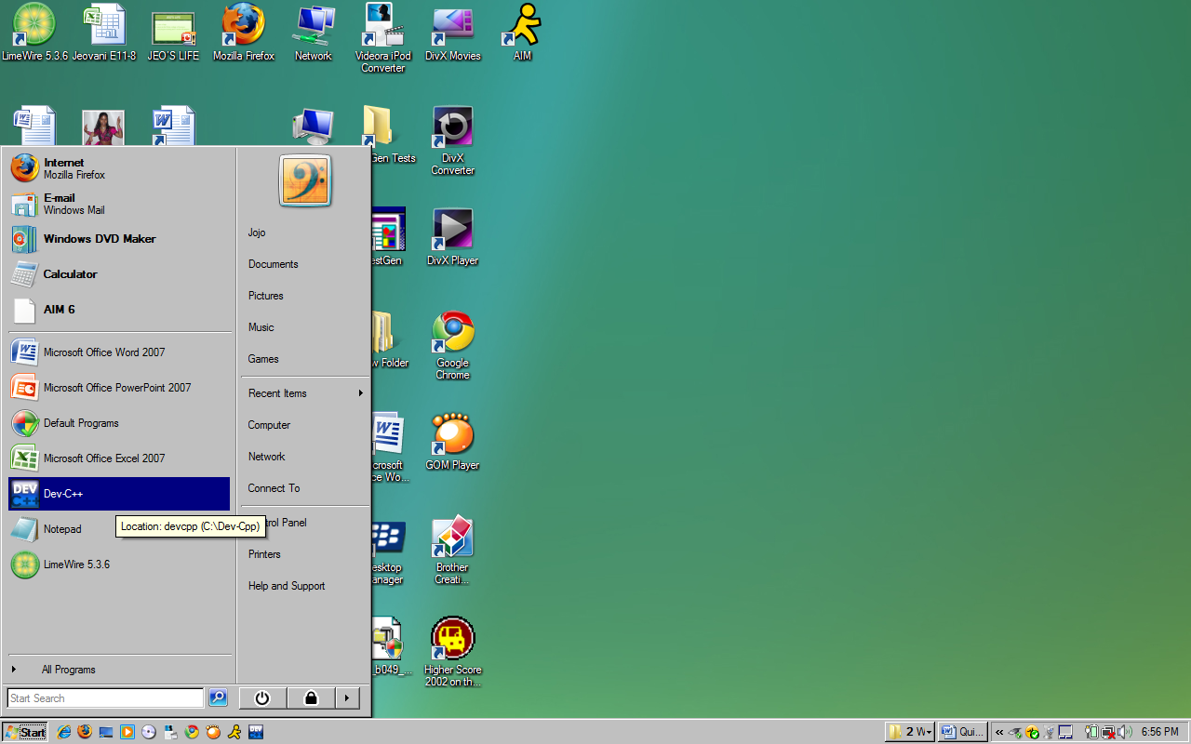

After you select Dev C++ the following screen will appear.
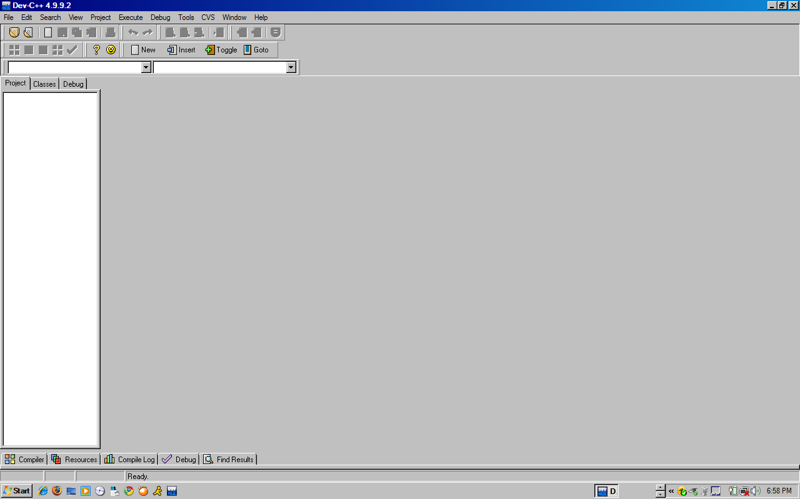
SOURCE FILE
Now, go up to the tool bar at the top of the screen and click on file. Select New and then Source File.

WRITING A PROGRAM
Start typing, then click on the execute button on the tool bar, after which you will select the compile button. Then you will be given the chance to save this file. Create a name for the file if you wish, and select save to continue. This will be demonstrated in Question 9.
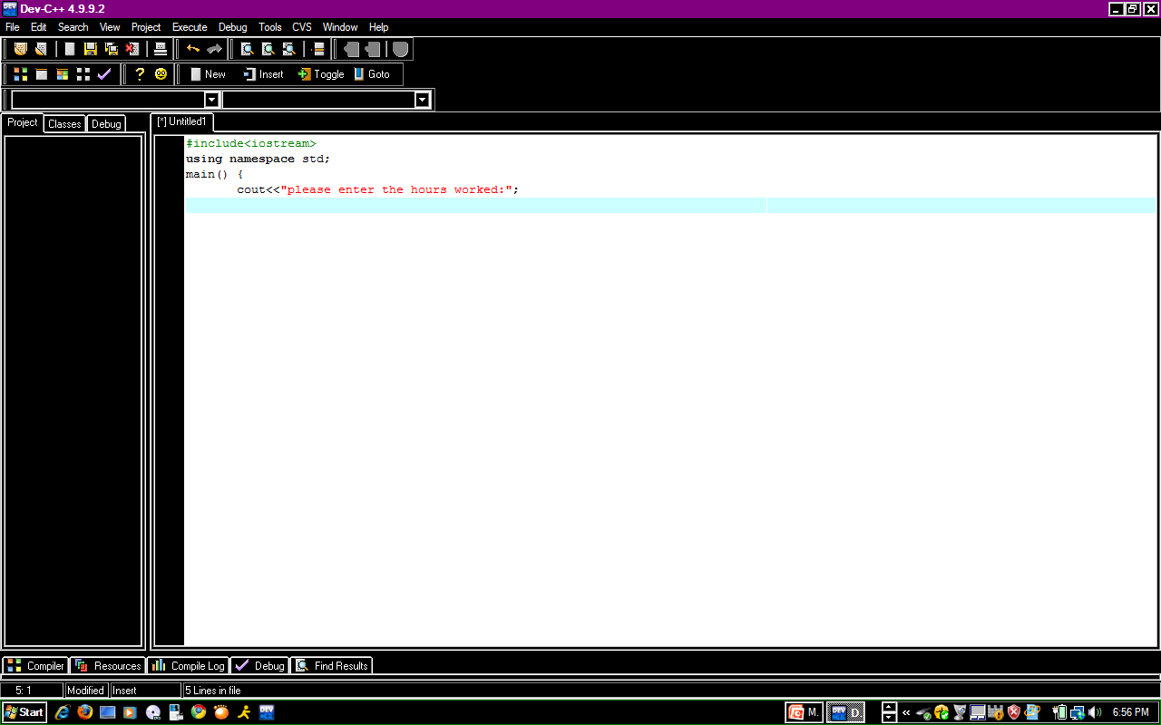

- How to compile a program?
This is a simplest task of all. Find the compiler tab on the top bar and click on it (you can find a shortcut key like F5 or Ctrl+5)

A screen will appear prompting you to name the file and save it before you can compile it.
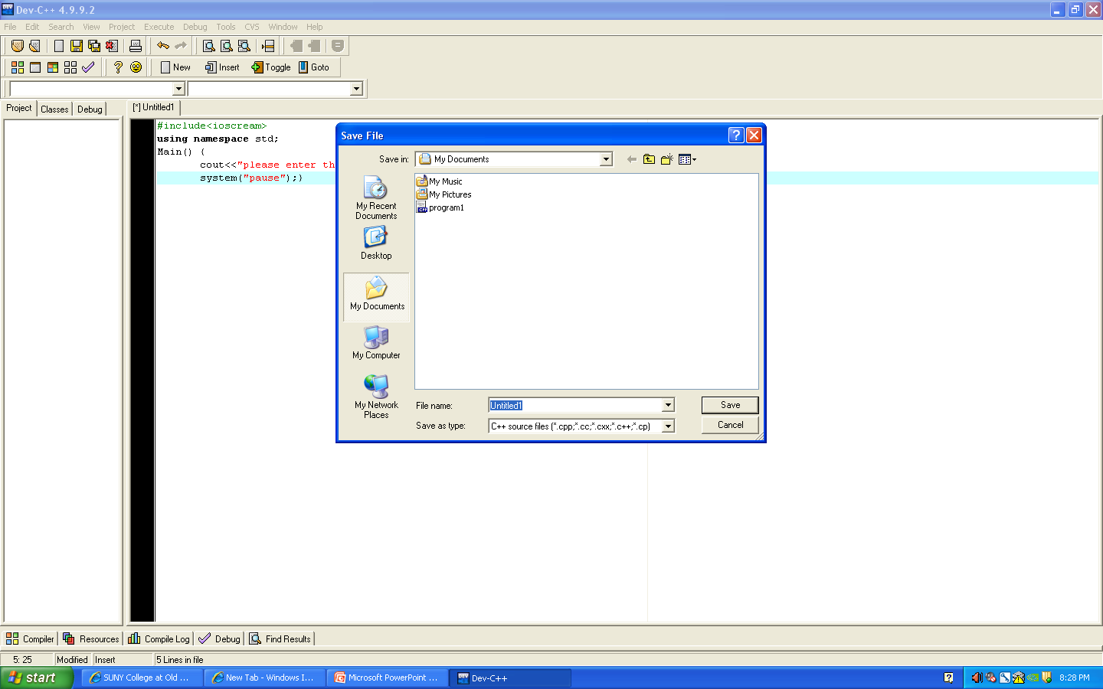
If there are errors the following screen will appear.
If there are no errors the following screen will appear.
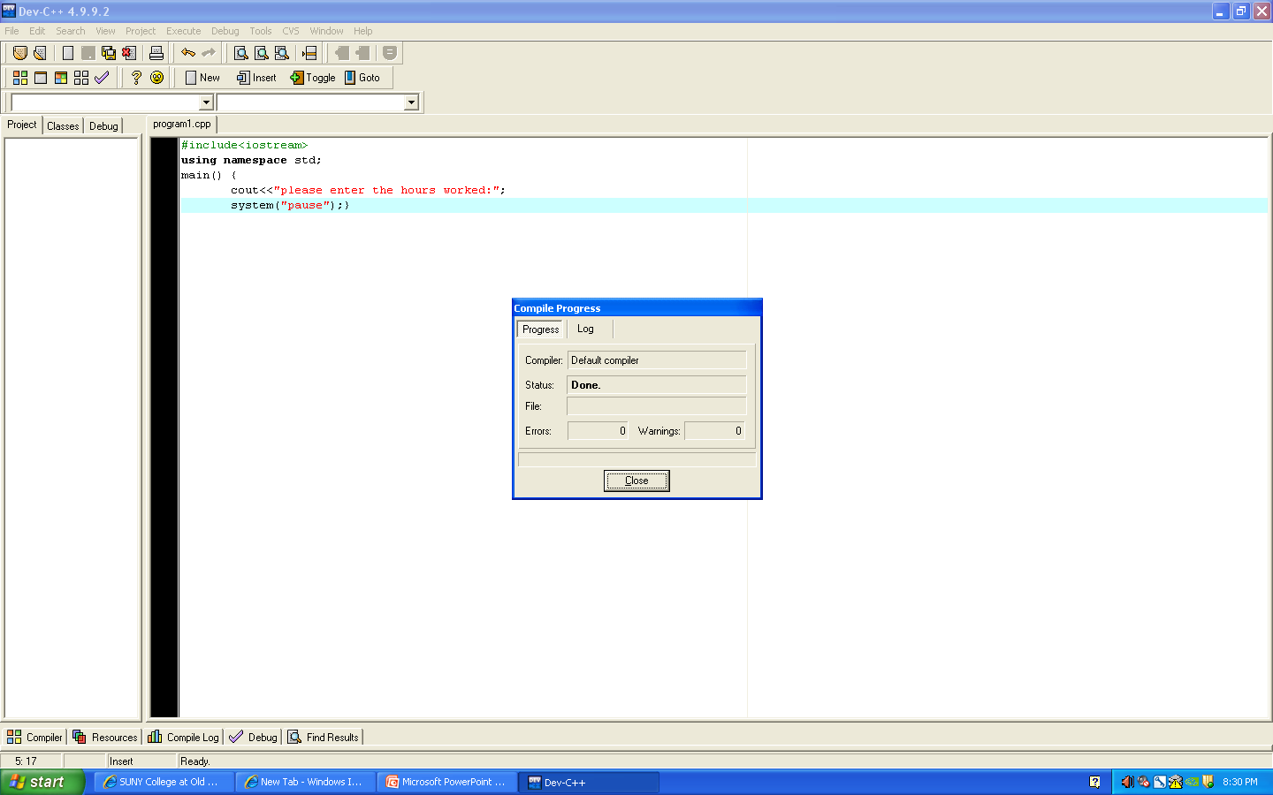
- How to find the syntax errors of the compile program.
A compiler will highlight the statement that contains errors (red color) and at the bottom of page will the line, the word and the cause of error will be indicated. However, the language of the explanation is hard to understand, it may require time and you may not need to look at the messages anymore for the guidance.

If you see the following screen it means you have a syntax error and need to review what you wrote to see if you misspelled something or just wrote the incorrect thing. If you look to the bottom of this screen you will see that the errors are listed for you.

- How to fix the syntax errors of compiled program.
Look at the error message and look at the grammar of the statement in the error and try to reason it out. When you fix of an error it may cause new errors. The Syntax errors eventually will be resolved.
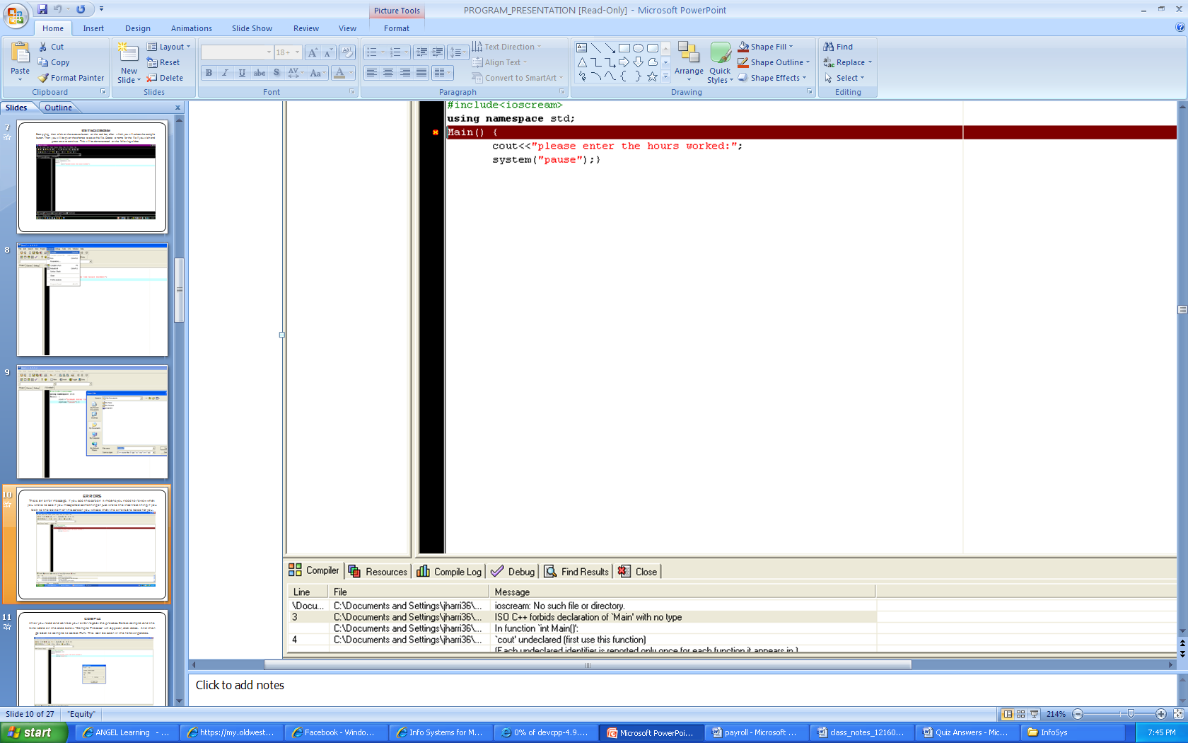
Testing is created to find errors. When you look at the list of errors located at the bottom of the screen in this example, it claims that “ioscream” is not a file. In this case, there was a spelling error and it should have been written as “iostream”. After you read and correct your error repeat the process. Select compile and the little table on the slide below “Compile Process” will appear, click close.
Now that you have corrected the error(s) the compile progress table will state that there are zero errors.
- How to run the complied program and see the output.
Go to Execute on the toolbar and select “run”.
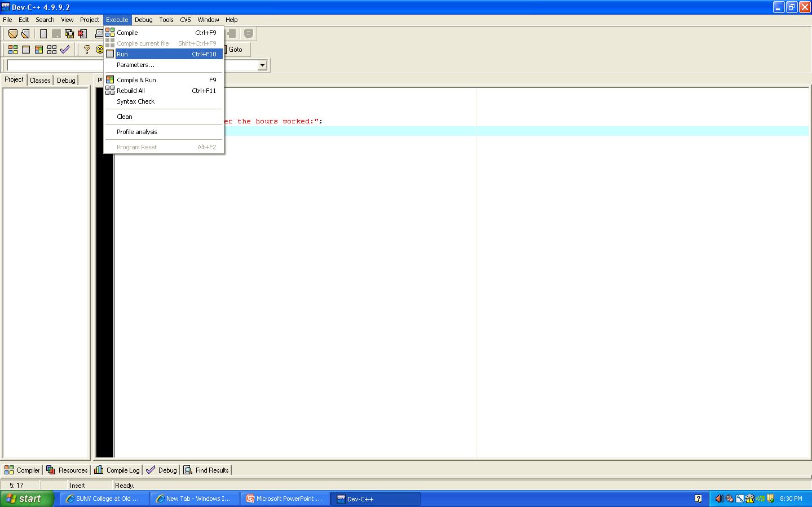

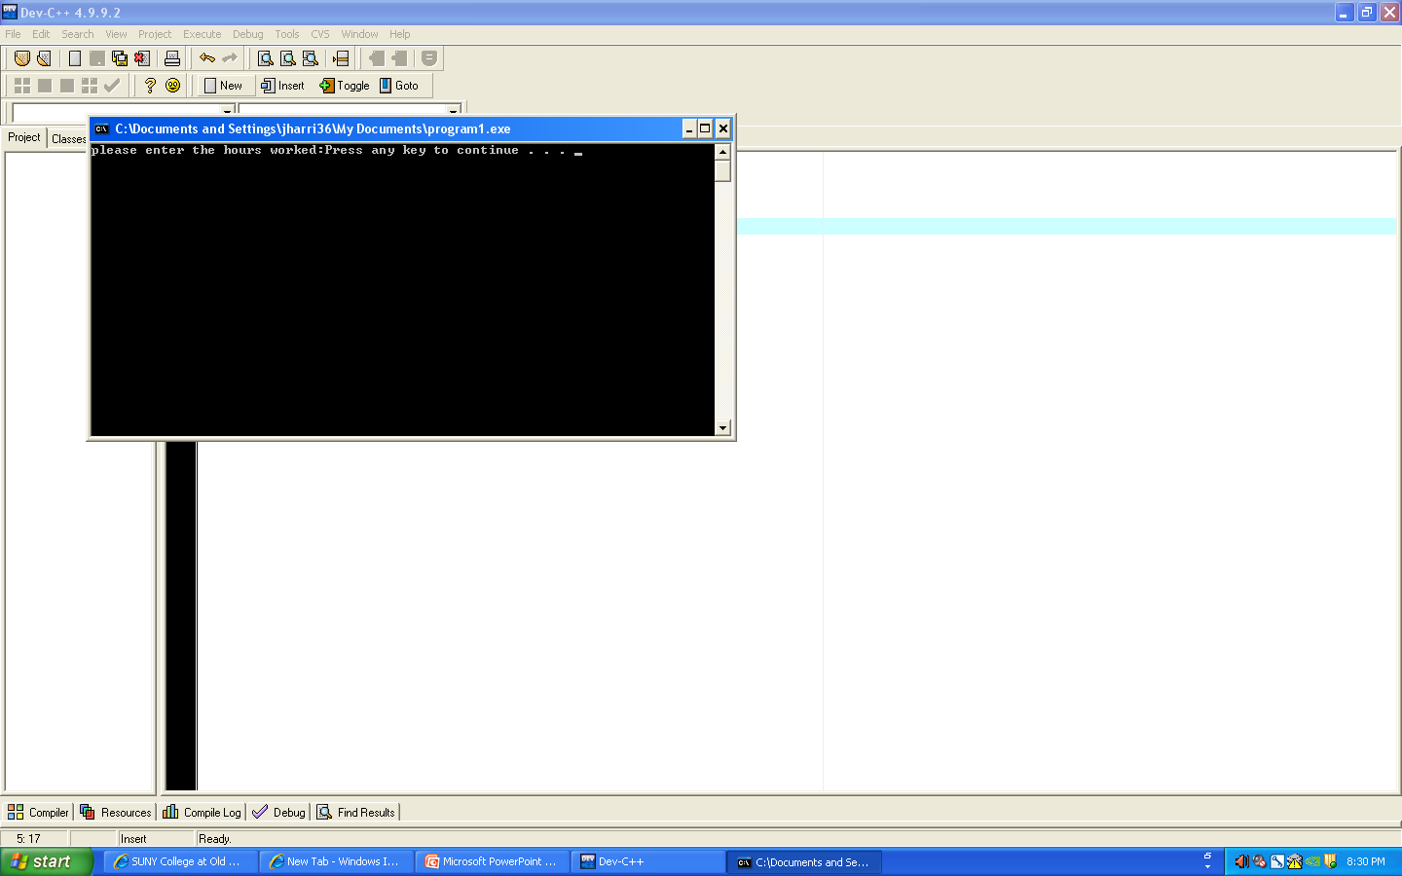

Your program will only begin to make calculations after writing a program like the one below.

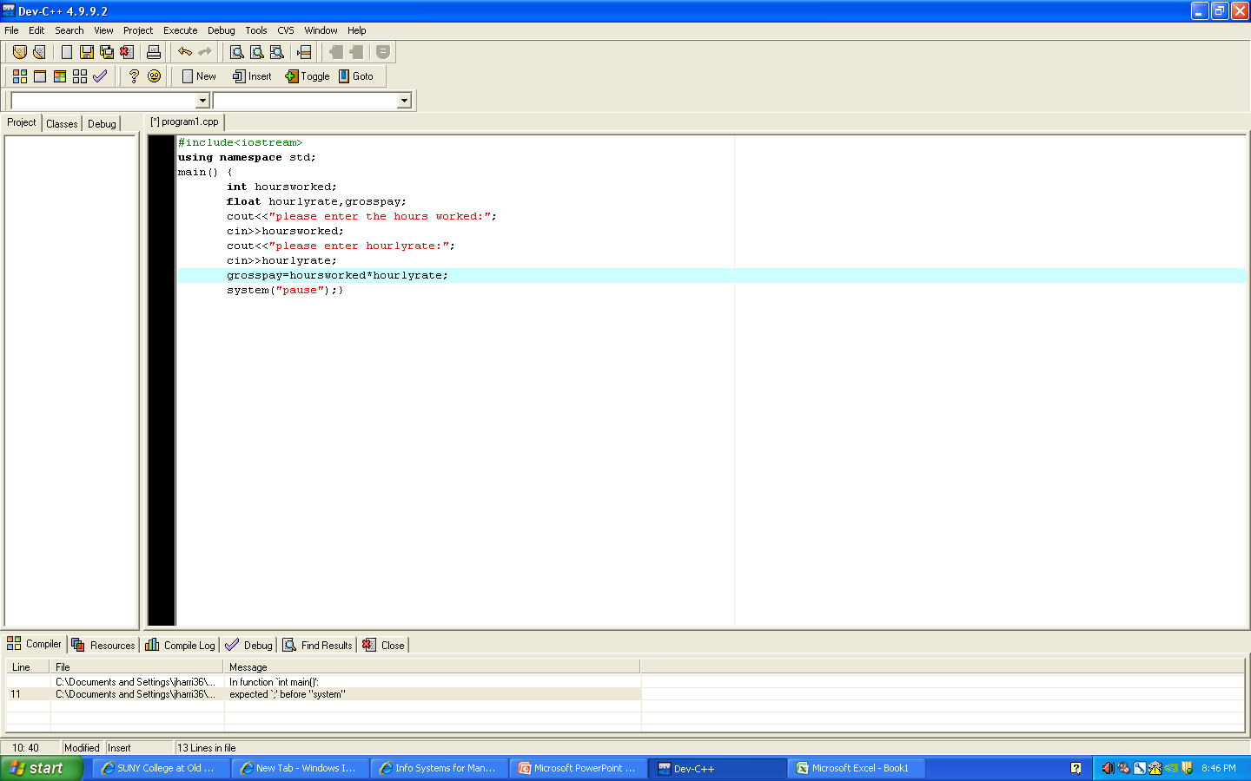

When you run this program it will look like this:

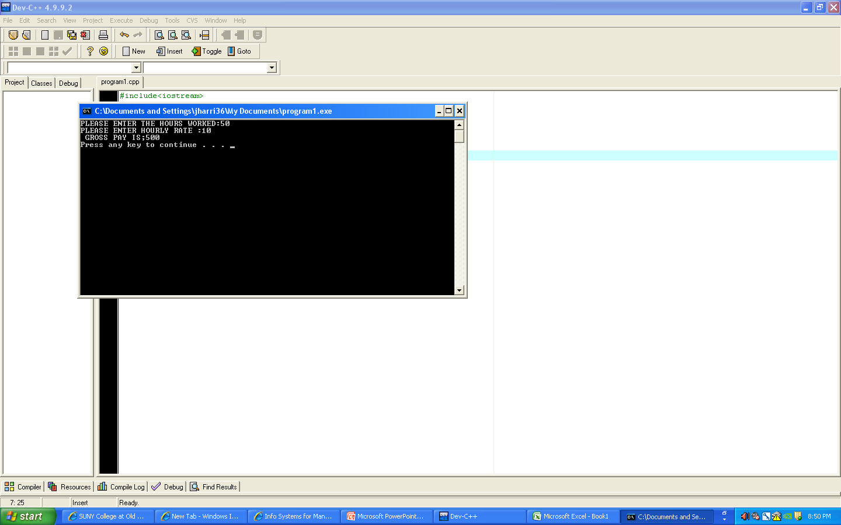

- How to find and fix the logical errors of the program if any. A logical error may take minutes, days, years to be found or fixed or may never found.
Logic errors hinder your program from completing intended tasks. The compile progress may show no errors, nevertheless you may get and unexpected result.
For instance, if your program has two variable that are connected, such as city and state, that you expect to be displayed together when running the program; however, when you run your program, if only the city is displayed, it may mean you have a logical error because a value was not given to the state. This error can be fixed by assigning a value to the state. Because the program may still run without fixing such an error, it is one of the hardest errors to find.
- What are the problems with programming?
- There is a lack of programming education available to students in most schools. Schools that do have such education, have a limited amount of programming classes.
- Some experts believe the teaching material and/or software are flawed.
- Programming languages are not user friendly.
- Programming languages are outdated. Technology has evolved at a faster rate than the languages.
- Programmers are developing programs without spending time to figure out when and why a specific action is performed. Because of this when an error occurs, it takes longer to fix.
- Why is it hard to learn programming?
- The programming language is different from human language. For example an * is used instead of an x for the purpose multiplication. Due to the fact that some people cannot understand this, it hinders the learning process.
- Few schools offer creditable programming classes.
- People who are not interested in programming tend to find learning about it tedious.
- How does a program look like? Show me a big picture.
This is an example of a search program found on Dr. Ebrahimi’s website.
1. #include <stdio.h>
2. #include <string.h>
3.
4. int main(){
5. char searchname[15], name[15], telephone[14];
6. FILE *fp;
7. printf ( "ENTER THE SEARCH NAME: " );
8. scanf ( "%s", searchname );
9. fp = fopen ( "data.in", "r" );
10. while( fscanf( fp,"%s%s", name, telephone ) != EOF ){
11. if( strcmp ( searchname, name ) == 0 ){
12. printf( " %s\n", telephone );
13. return 0;
14. } /* end of if */
15. } /* end of loop */
16. printf( "NAME NOT FOUND\n" );
17. return 0;
18. } /* end of main */

The following is an example of a completed payroll program.
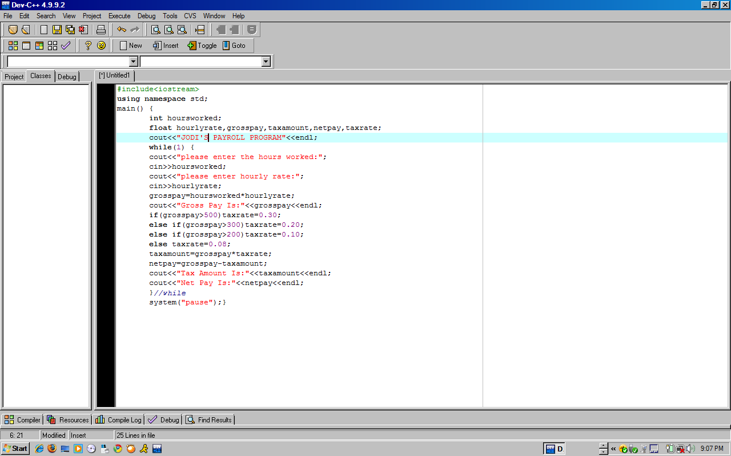

When you run the program you will see a screen such as the one that is displayed below.
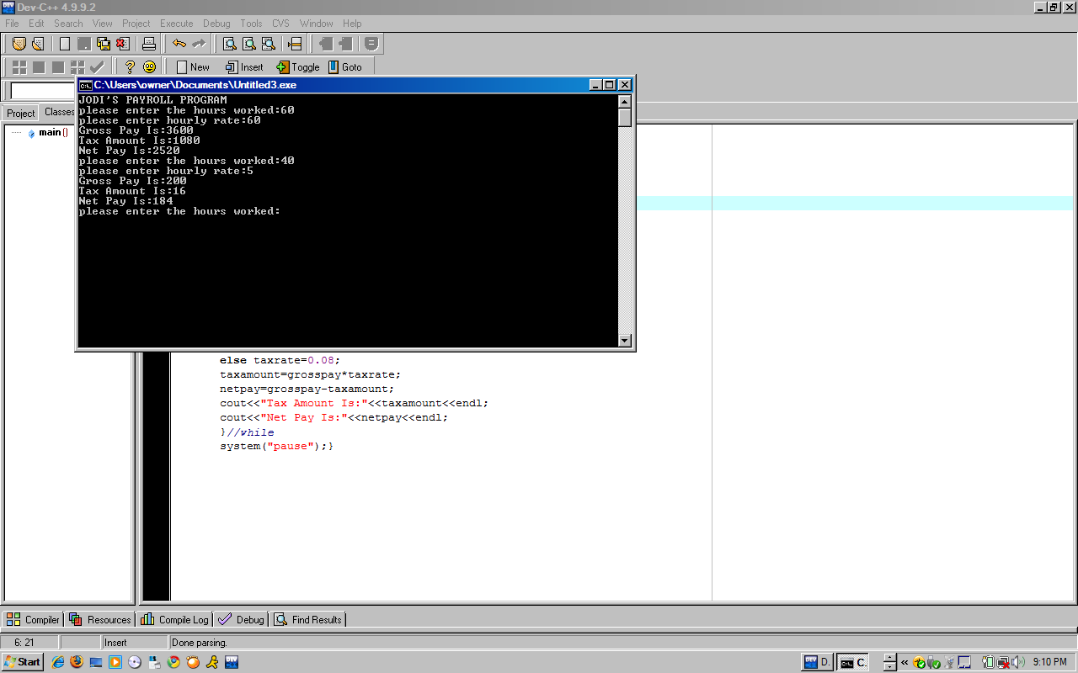
- What/why a manager needs to understand programming?
A manager needs to have basic understanding of programs, programming and programming language. If the learn more about these concepts they will come across the various issues that get in the way of executing various tasks. Once they grasp these issues they will be better able to handle, work with, and perhaps overcome these imperfections. Also, managers who have knowledge of programming will have an edge competitively and generally.
- What is data file?
A data file is a file in the computer that is stored to later be used by a program.
- What are the 10 most keywords of C++ Programming?
- #include<iostream> - used as the first line of the program writing.
- main() { - after this statement lies the function your program will perform
- int – this stands for “integer”, after int you leave a space and type the first variable you use for input. Used with whole numbers.
- float – leave a space and type the rest of the input variables after this word. Used with fractions.
- while (1) { – this command tells the program to “loop” or repeat after all the tasks are completed.
- if- else statement – this statement allows you to put restrictions on your program. For example in the program created above the if-else statement controls the tax rate by increasing the tax rate when gross pay reaches a certain amount.
- cout- this is used before a statement to tell the computer to output the statement. This is what the computer asks for.
- cin- this is used before a variable that stands for the response to the statement in the cout before it. This is the response to what the computer asks for.
- system (“pause”) – this command stops the screen that appears when you run your program from disappearing.
- ; - semicolons are very important to put at the end of each command. It’s like putting a period after each sentence when you write an essay.
- What is problem solving, and name five important programming concepts which with that you program any problem solution.
Problem solving is resolving a conflict or question by figuring out a solution. You can use programming to have a computer solve problems for you. Five examples of how programming can be used in problem solving are:
- Payroll calculations
- Search engines
- Translating
- Solving mathematical problems
- Comparing data

Works cited

Rainer, K. R., Turban, E., & Potter, R. (2010). Introduction to Information Systems: Supporting and Transforming Business. New Jersey: John Wiley & Sons, Inc.

